# 实验三 析构函数和构造函数

程序代码:

#include<iostream>

using namespace std;

class Score {

public:

Score()

{

Students = 2;

}

Score(int number)

{

Students = number;

}

~Score()

{

}

int i = 1;

void getgrade()

{

for (i = 1;i <= Students; i++) {

cout << "请输入学生姓名：" << endl;

cin >> name[i];

cout << "请输入科目A的成绩：" << endl;

cin >> a[i];

cout << "请输入科目B的成绩：" << endl;

cin >> b[i];

cout << "请输入科目C的成绩：" << endl;

cin >> c[i];

}

}

void showgrade()

{

for (i = 1;i <= Students;i++)

{

cout <<"姓名："<<name[i] << "科目A的成绩：" << a[i] <<" " << "科目B的成绩：" << b[i]<<" " << "科目C的成绩：" << c[i]<<" " << endl;

}

}

void showavgstu()

{

for (i = 1;i <= Students;i++)

{

cout <<name[i]<<":" << ((a[i] + b[i] + c[i]) / 3);

}

}

void showclassgrade(char f)

{

float avg = 0;

if (f == 'a')

{

for (i = 1; i <= Students;i++)

{

avg = avg+a[i];

}

avg = avg / Students;

cout << "课程名称:A" << "平均成绩:" << avg << endl;

}

if (f == 'b')

{

for (i = 1; i <= Students;i++)

{

avg = avg + b[i];

}

avg = avg / Students;

cout << "课程名称:B" << "平均成绩:" << avg << endl;

}

if (f == 'c')

{

for (i = 1;i <= Students;i++)

{

avg = avg + c[i];

}

avg = avg / Students;

cout << "课程名称:C" << "平均成绩：" << avg << endl;

}

}

private:

int Students;

float a[100], b[100], c[100];

string name[100];

};

int main()

{

Score A;

A.getgrade();

A.showgrade();

A.showclassgrade('a');

A.showavgstu();

return 0;

}

运行结果：

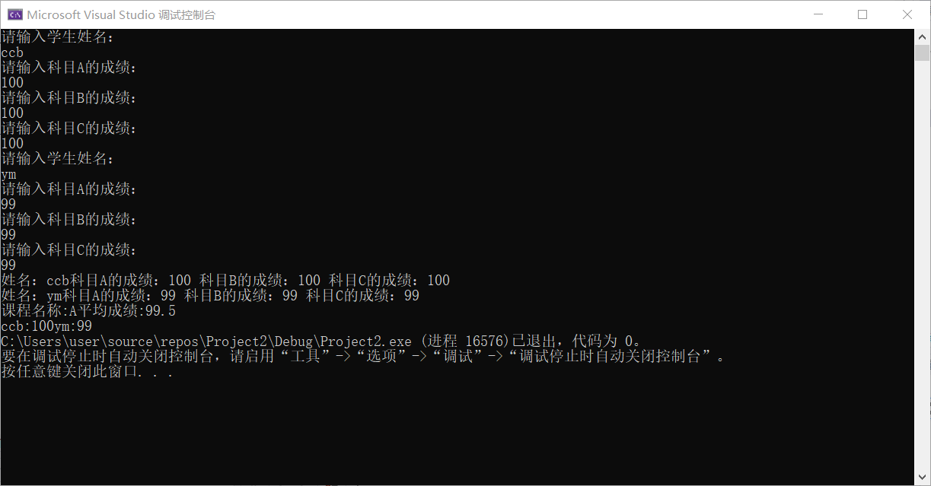

心得体会：

构造函数的作用是为对象分配空间，进行初始化，函数名与类名相同且没有返回值类型，甚至定义为void也不行，析构函数的作用正好与构造函数相反，它负责撤销存储空间。经过此次实验，我已经加深了对类和对象的理解，并且能够熟练的运用构造函数和析构函数来解决问题。

Copyright ©2021-2099 Tianhang Li. All rights reserved